TASK1
#include <stdio.h>

int main() {
float distance, total_fare;
int hour;

printf("Enter the distance traveled in kilometers: ");
scanf("%f", &distance);

printf("Enter the hour of the day (0-23): ");
scanf("%d", &hour);

if (distance <= 0) {
printf("Invalid Distance\n");
return 0;
}
if (distance <= 1) {
total_fare = 50.0;
} else {
total_fare = 50.0 + (distance - 1.0) * 22.0;
}

if (hour < 6 || hour > 22) {
total_fare += 40.0;
}
printf("Total Fare: Rs %.2f\n", total_fare);

return 0;
}
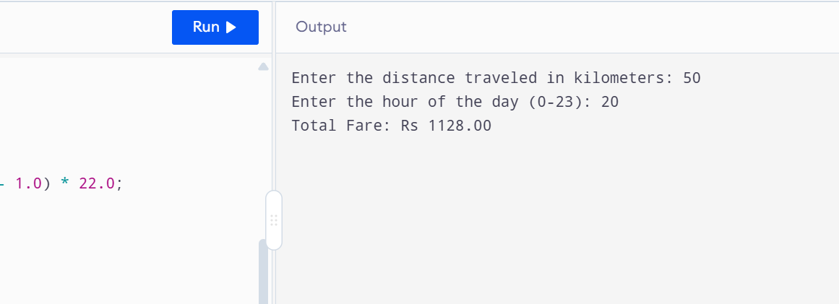

TASK2
#include <stdio.h>

int main() {
float total_bill, discount_amount = 0.0, final_payable = 0.0;
int membership_status;
printf("Enter the total bill amount: ");
scanf("%f", &total_bill);

printf("Enter membership status (1 for Member, 0 for Non-Member): ");
scanf("%d", &membership_status);

if (total_bill < 500.0) {
discount_amount = 0.0;
}
else if (total_bill >= 500.0 && total_bill <= 1999.0) {
if (membership_status == 1) {
discount_amount = total_bill * 0.10;
} else {
discount_amount = total_bill * 0.05;
}
}
else if (total_bill >= 2000.0) {
if (membership_status == 1) {
discount_amount = total_bill * 0.15;
} else {
discount_amount = total_bill * 0.08;
}
}

final_payable = total_bill - discount_amount;
printf("Discount Amount: Rs %.2f\n", discount_amount);
printf("Final Payable Amount: Rs %.2f\n", final_payable);

return 0;
}
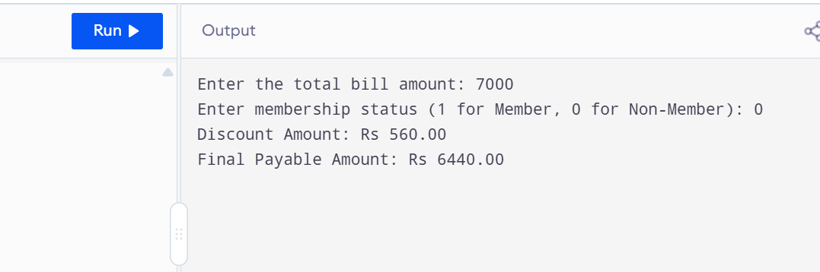

TASK3
#include <stdio.h>

int main() {
int marks;
printf("Enter marks obtained (out of 100): ");
scanf("%d", &marks);

if (marks < 0 || marks > 100) {
printf("Invalid Marks\n");
return 0;
}

if (marks >= 90) {
printf("Grade: A+\n");
printf("Result: Pass\n");
}
else if (marks >= 80) {
printf("Grade: A\n");
printf("Result: Pass\n");
}
else if (marks >= 70) {
printf("Grade: B\n");
printf("Result: Pass\n");
}
else if (marks >= 60) {
printf("Grade: C\n");
printf("Result: Pass\n");
}
else if (marks >= 50) {
printf("Grade: D\n");
printf("Result: Pass\n");
}
else {
printf("Grade: F\n");
printf("Result: Fail\n");
}

return 0;
}
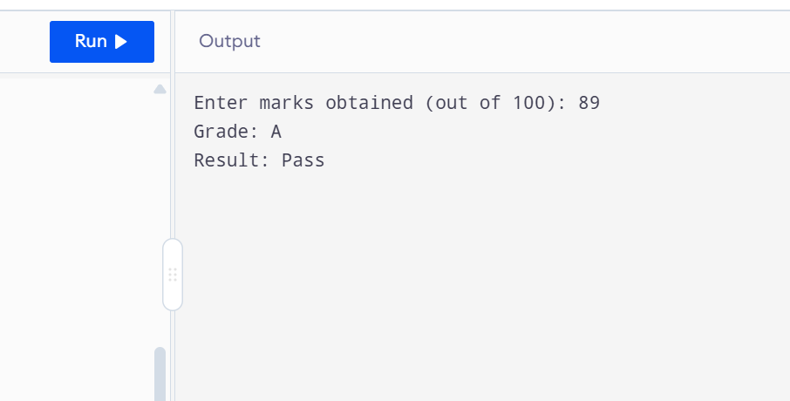

TASK4
#include <stdio.h>

int main() {
int capacity, current_level, remaining_liters;
float fill_rate, required_time, electricity_cost;
int rounded_minutes;

printf("Enter tank capacity (in liters): ");
scanf("%d", &capacity);

printf("Enter current water level (in liters): ");
scanf("%d", &current_level);

printf("Enter motor fill rate (liters per minute): ");
scanf("%f", &fill_rate);

if (current_level >= capacity) {
printf("Tank Already Full\n");
return 0;
}

remaining_liters = capacity - current_level;
required_time = (float)remaining_liters / fill_rate;

rounded_minutes = (int)required_time + (required_time > (int)required_time);

electricity_cost = rounded_minutes * 3.50;

printf("Required Time: %.2f minutes\n", required_time);
printf("Billed Electricity Cost: Rs %.2f\n", electricity_cost);

return 0;
}
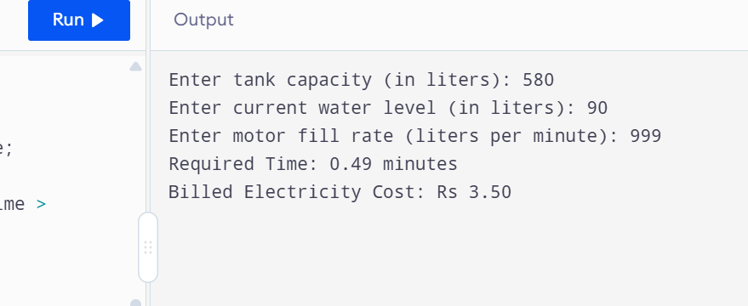

TASK5
#include <stdio.h>

int main() {
float load_amount, bonus_percent = 0.0, bonus_amount = 0.0, final_balance = 0.0;
int network_code, weekend_status;

printf("Enter the mobile load amount: ");
scanf("%f", &load_amount);

printf("Enter network code (1 = Jazz, 2 = Telenor, 3 = Ufone): ");
scanf("%d", &network_code);

printf("Enter weekend status (1 = Weekend, 0 = Weekday): ");
scanf("%d", &weekend_status);

if (load_amount < 100.0) {
bonus_percent = 0.0;
}
else if (load_amount >= 100.0 && load_amount <= 499.0) {
if (weekend_status == 1) {
if (network_code == 3) {
bonus_percent = 5.0;
} else {
bonus_percent = 10.0;
}
} else {
bonus_percent = 5.0;
}
}
else if (load_amount >= 500.0) {

if (network_code == 1) {
bonus_percent = 20.0;
} else {
if (weekend_status == 1) {
bonus_percent = 20.0;
} else {
bonus_percent = 12.0;
}
}
}

bonus_amount = load_amount * (bonus_percent / 100.0);
final_balance = load_amount + bonus_amount;

printf("Bonus Amount: Rs %.2f\n", bonus_amount);
printf("Final Loaded Balance: Rs %.2f\n", final_balance);

return 0;
}
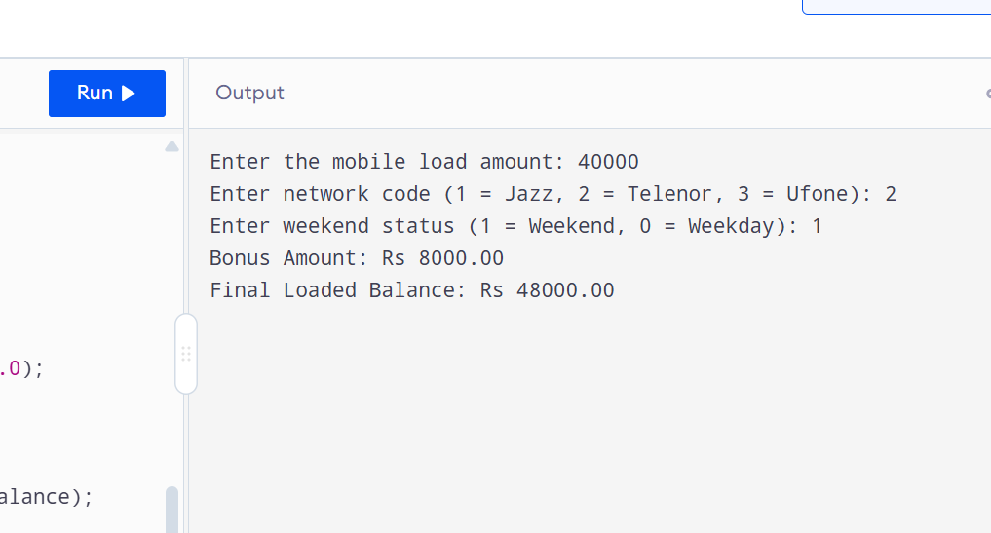

TASK6
#include <stdio.h>

int main() {
int overdue_days, book_type, priority_member;
float base_fine = 0.0, discount = 0.0, final_fine = 0.0;

printf("Enter number of overdue days: ");
scanf("%d", &overdue_days);

printf("Enter book type (1 = Regular, 2 = Reference, 3 = Rare): ");
scanf("%d", &book_type);

printf("Enter priority membership status (1 = Yes, 0 = No): ");
scanf("%d", &priority_member);

if (book_type == 1) {

if (overdue_days <= 7) {
base_fine = overdue_days * 5.0;
} else {
base_fine = (7 * 5.0) + ((overdue_days - 7) * 10.0);
}
}
else if (book_type == 2) {
base_fine = overdue_days * 15.0;
}
else if (book_type == 3) {
base_fine = overdue_days * 30.0;
}

if (priority_member == 1) {
if (book_type != 3) {
discount = base_fine * 0.20;
}
}

final_fine = base_fine - discount;

printf("Total Fine: Rs %.2f\n", final_fine);

if (book_type == 3) {
if (overdue_days > 10) {
printf("Banned from Borrowing\n");
}
}

return 0;
}
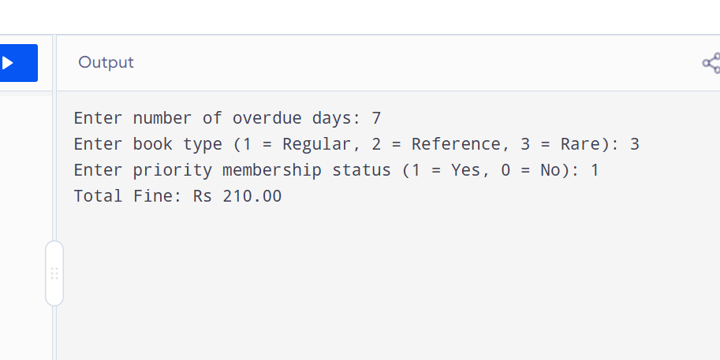

TASK7
#include <stdio.h>

int main() {
float batting_average;
int matches_played;
int fitness_failure_status;

printf("Enter batting average: ");
scanf("%f", &batting_average);
printf("Enter matches played: ");
scanf("%d", &matches_played);
printf("Enter fitness failure status (1 for Failed, 0 for Passed): ");
scanf("%d", &fitness_failure_status);

if (matches_played < 5) {
printf("Rejected — Insufficient Matches\n");
}

else if (fitness_failure_status == 1) {
printf("Rejected — Fitness\n");
}

else if (batting_average >= 35.0 && matches_played >= 10) {
printf("Selected\n");
}

else if (batting_average >= 25.0 && batting_average < 35.0 && matches_played >= 20) {
printf("Selected (Experience Quota)\n");
}
else {
printf("Not Selected\n");
}

return 0;
}
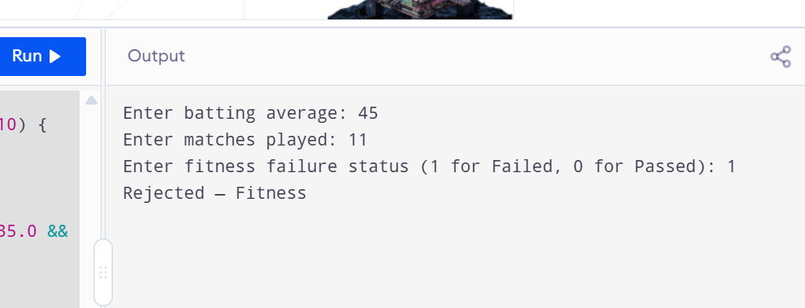

TASK8
#include <stdio.h>

int main() {
int meal_category;
double bill_amount;
int customer_type;

double service_charge_percent = 0.0;
double discount_percent = 0.0;

printf("Enter meal category (1=Fast Food, 2=Desi Food, 3=Chinese): ");
scanf("%d", &meal_category);
printf("Enter bill amount: ");
scanf("%lf", &bill_amount);
printf("Enter customer type (1=Student, 2=Regular): ");
scanf("%d", &customer_type);

if ((meal_category < 1 || meal_category > 3) || (customer_type < 1 || customer_type > 2)) {
printf("Invalid Selection\n");
return 0;
}

switch (meal_category) {
case 1:
service_charge_percent = 0.05;
break;
case 2:
service_charge_percent = 0.08;
break;
case 3:
service_charge_percent = 0.10;
break;
}

double service_charge = bill_amount * service_charge_percent;

if (bill_amount >= 1000.0) {
if (customer_type == 1) {
discount_percent = 0.15;
} else {
discount_percent = 0.10;
}
} else {
if (customer_type == 1) {
discount_percent = 0.05;
} else {
discount_percent = 0.00;
}
}
double discount_amount = bill_amount * discount_percent;
double final_payable = bill_amount + service_charge - discount_amount;

printf("\n--- Bill Summary ---\n");
printf("Service Charge: Rs %.2f\n", service_charge);
printf("Discount: Rs %.2f\n", discount_amount);
printf("Final Payable: Rs %.2f\n", final_payable);

return 0;
}


